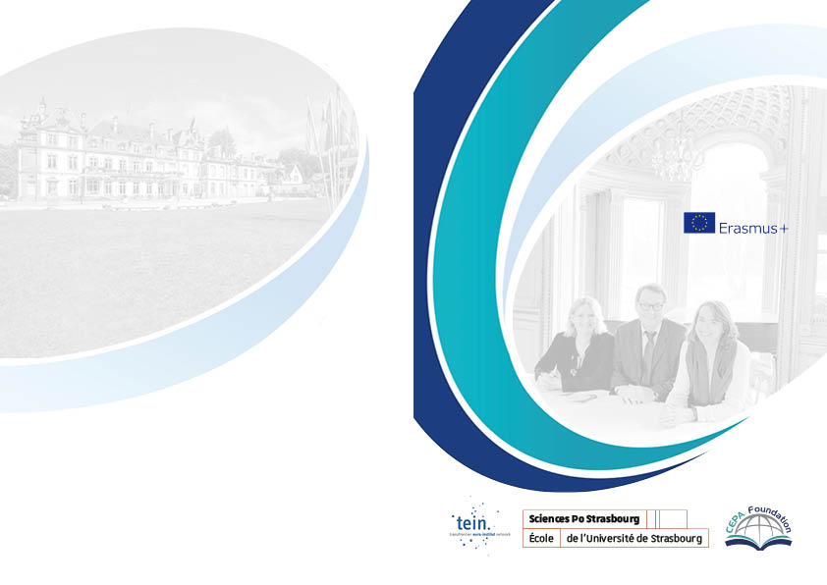
Venue

Location

Château de Pourtalès
161, rue Mélanie
67000 Strasbourg

Acces

From Strasbourg Station
Tram line A or D to Place de l’Etoile, cross to the Quai du Général Koenig at Place du Maréchal de Lattre-de-Tassigny take Bus n°15 direction Robertsau, to bus stop Lamproie, from there follow rue Mélanie to the château.

Online registration required at :

https://us02web.zoom.us/meeting/register/tZcrduGgqjksE9bq3GCbAk370NjIIkKIBo7c
Contact: Marc-Antoine Maes
m.maes@unistra.fr

Castle Talks on
Cross-Border Cooperation
The migration crisis
A challenge for border regions

Jean Monnet Project
18 January 2021

At the Château Pourtalès
161, rue Mélanie
Strasbourg

Program

18 January: morning

8.30-9.45
Welcome:
Harald LEIBRECHT (CEPA Programme, Strasbourg)

Introduction:
Birte WASSENBERG (Sciences Po Strasbourg, Centre d’excellence Jean Monnet, Strasbourg)

Key Notes:
Petia TZVETANOVA (MOT)
Gyula OKSKAY (CESCI)

Panel
Anja BARTEL (University of Strasbourg)
Noriko SUZUKI (Waseda University, Tokyo)

Session chair : Bernard REITEL (Université d’Artois)

First part: Exchange of experience
The migration crisis in Europe: an exceptional case?

9.45-10.45
Working group 1:
Sciences Po Student working group Mond
Discussant:
Anne HOFMANN (Euro-Institut Kehl)

Working group 2:
Sciences Po Student working group Front
Discussant:
Petia TZVETANOVA (MOT)

Coffee Break

11.00-12.30

Working group 3:
Sciences Po Student working group Mond
Discussant:
Gyula OKSKAY (CESCI)

Working group 4:
Sciences Po Student working group Front
Discussant:
Frédérique BERROD (Sciences Po Strasbourg)

Working group 5:
Faculty of Law Student working group:
Discussant:
Bernard REITEL (Université d’Artois)

Afternoon

14.00-14.45

Introduction:
Bernard REITEL (Université d’Artois)

Key note:
Catherine DELCROX (University of Strasbourg)
Machteld VENKEN (University of Luxembourg)

Session chair: Joachim BECK (University of Kehl)

First Part: Migration, identity and borders
Exchange of experience

14.45-15.45

Working group 6:
Sciences Po Student working group Mond
Discussant:
Frédérique BERROD (Sciences Po Strasbourg)

Working group 7 :
Sciences Po Student working group Front
Discussant:
Anja BARTEL (University of Strasbourg)

Coffee Break

Second Part: Migration crisis and human Rights: a challenge for the EU

Exchange of experience
16.00-18.00

Working group 8:
Sciences Po Student working group Mond
Discussant:
Catherine DELCROX (University of Strasbourg)

Working group 9:
Sciences Po Student working group Front
Discussant:
Machteld VENKEN (University of Luxemburg)

Working group 10:
Sciences Po Student working group Mond
Discussant:
Bernard REITEL (Université d’Artois)

Working group 11:
Sciences Po Student working group Front
Discussant:
Joachim BECK (University of Kehl)

18.00-18.30

Panel :
Céline LE FLOUR Master 2 FRONT Sciences Po
Claude BEAUPRE (University of Strasbourg/Uvic)

Birte WASSENBERG (Sciences Po Strasbourg)

Conclusion

